HARROW COUNCIL

ADDENDUM

PLANNING COMMITTEE

DATE: 13TH DECEMBER 2023

2/023 | 26 The Chase, Edgware, HA8 5DJ
Republish report without comments in the margins:-

LONDON BOROUGH OF HARROW

PLANNING COMMITTEE

13th December 2023

APPLICATION NUMBER: | P/1643/23
VALID DATE: | 07th SEPTEMBER 2023
LOCATION: | 26 THE CHASE, EDGWARE, HARROW
WARD: | EDGWARE
POSTCODE: | HA8 5DJ
APPLICANT: | MR. KUJDESI
AGENT: | HGH CONSULTING
CASE OFFICER: | DENISS NIKANDROVS
EXPIRY DATE: | 14/08/2023

PROPOSAL

Conversion of dwelling into two flats (2 X 2 bed); single storey rear extension; external alterations; separate amenity space; bin and cycle stores; new roof to front porch; raised patio at rear (demolition of conservatory and side projection, and removal of swimming pool and enclosure)

RECOMMENDATION

The Planning Committee is asked to:

1) Agree the reasons for approval as set out in this report, and

2) Grant planning permission subject to the Conditions listed in Appendix 1 of this
report.

REASON FOR THE RECOMMENDATION

The proposal would contribute towards housing stock within the Borough and the quality of accommodation for the future. It would not detract from the character and appearance of the host building, street scene and area in a wider context. It would provide a suitable quality of accommodation for future occupiers without unduly impacting neighbouring residential amenity. It is not considered to result in significantly adverse traffic and parking impacts. The development’s proposed refuse storage arrangements are considered to be acceptable as are the cycle storage arrangements. The development is not considered to be susceptible to harmful flood risk and is not considered to unduly exacerbate flood risk elsewhere. In light of the above, subject to conditions, the proposed development would be in accordance with the National Planning Policy Framework (2023), The London Plan (2021), Policies D3, D4, D6, D12, T5, T6, SI 12, SI 13, Harrow Core Strategy (2012), Policy CS1, Harrow Development Management Polices Local Plan (2013), Policies DM1, DM2, DM10, DM12, DM22, DM23 DM24, DM26, DM27, DM42, DM45, Relevant Supplementary Documents: Technical Housing Standards Nationally Described Space Standards (2015), Mayor Of London, Housing Supplementary Planning Guidance (2016) and Supplementary Planning Document - Residential Design Guide (2010)

INFORMATION

This application is reported to Planning Committee at the request of a nominated member in the public interest.

Statutory Return Type: | 13.Minor Dwellings
Council Interest:  Net additional Floorspace: | None  Approximately 0 sqm
GLA Community Infrastructure Levy (CIL) Contribution (provisional): | Approximately £0 (Includes Indexation)
Local CIL requirement: | Approximately £0 (Includes Indexation)

HUMAN RIGHTS ACT

The provisions of the Human Rights Act 1998 have been taken into account in the processing of the application and the preparation of this report.

EQUALITIES

In determining this planning application the Council has regard to its equalities obligations including its obligations under section 149 of the Equality Act 2010.

For the purposes of this application there are no adverse equalities issues.

S17 CRIME & DISORDER ACT

The applicant has failed to provide sufficient detail on the proposed development’s resilience to crime. For the avoidance of doubt, a condition has been imposed requiring the applicant to submit evidence of certification of Secure by Design accreditation prior to the occupation of the development.

1.0 SITE DESCRIPTION

  - The host site is located on the north-eastern side of The Chase, consisting of a two-storey semi-detached dwellinghouse.

  - The surrounding area is predominantly residential, consisting of similar two-storey semi-detached dwellinghouses.

  - The surrounding area benefits from a large number of minor and large residential extensions.

  - The host site benefits from a considerable single storey rear extension which houses an existing swimming pool as well as a roof extension and large rear dormer.

  - The host site is not located within a conservation area and there are no listed buildings on or adjacent to the host property. The site is not within the green belt or a flood zone. The site has a PTAL rating of 3 (moderate).

2.0 PROPOSAL

2.1 The application seeks planning permission for the conversion of the dwelling into two flats (2 X 2 bed 3 persons units), a single storey rear extension, external alterations and other works including separate amenity spaces, new bin and cycle stores a new roof to the front porch and a raised patio at rear (following the demolition of conservatory and side projection, and removal of swimming pool and enclosure).

2.2 Rear Extension

- The applicant proposes the demolition of the existing 14.25 metre rear extension and swimming pool to the rear of the existing dwellinghouse as well as the side extension.
- Following the demolition of the existing ground floor structure, the applicant proposes a single storey rear extension.
- It would have a depth of 6 metres, a width of 5.7 metres and a height of 3 metres to the eaves of the flat roof.

Front Porch

- The proposed porch would have a retain the existing footprint with a depth of 1.1 metres and a width of 2.2 metres.
- The new dual pitched roof would have an eaves height of 3 metres and a maximum height of 3.7 metres.

Conversion

- The applicant would convert the existing single family dwellinghouse into 1no. 2b3p (2 bedroom 3 person) unit on the ground floor and a 2b3p unit on the upper floors as a maisonette.

Ground floor: Flat A 2b3p – 65sqm.
Upper floor Maisonette: Flat B 2b3p – 73.5sqm.

- The rear garden would be subdivided into private amenity spaces for both flats. The amenity spaces would provide 70sqm and 80sqm for flats A and B respectively, with both spaces providing hard and soft landscaping as well as cycle storage for 2no. spaces each. Bins would be located within the rear amenity space following amended plans.
- 2no. car spaces are proposed within the front amenity space.

3.0 RELEVANT PLANNING HISTORY

  - A summary of the relevant planning application history is set out below:

Ref no. | Description | Status & date of decision
LBH/35606 | Front porch | Granted 02/06/1988
LBH/34535 | Erection of brick wall 1.5 metre high with piers 1.65 metres high and gates to enclose new parking space in front garden | Granted 12/02/1988
P/0860/23 | CERTIFICATE OF LAWFUL DEVELOPMENT (PROPOSED):  Alterations and extension to roof to form end gable; rear dormer; two rooflights in front roof slope; window in end gable | Granted 15/05/2023

4.0 CONSULTATION

4.1 A Site Notice was posted on 09/08/2023 and was set to expire on 30/08/2023.

4.2 A total of 4 consultation letters were sent to neighbouring properties regarding this application.

4.3 The public consultation period expired on 11th July 2023, a total of 3.no objections have been received.

4.4 The objections raised have been summarised and responded to in the table below:

Summary of Matters Raised | Officer Response
Surrounding area traditional residential housing | The proposed development would only result in a net increase of 1 unit, with both units being small family dwellings. The increase of occupants resulting from the proposal is not considered to be excessive. Furthermore, it should be noted that there are no local plan policies which preclude the provision of new dwellings along The Chase, it would be unreasonable to refuse the application on this basis.
Neighbours have not been consulted on the scheme | Neighbours have been consulted sufficiently on the proposed scheme as detailed below.
Potential to devalue houses | This is not a material planning consideration and cannot be considered in the assessment of this application.
Create parking issues  . | The is addressed within the Traffic, Parking and Refuse Section of this Committee Report (6.3), furthermore, highways officers have deemed this proposal acceptable and have no objections to the proposed parking.
Increase footprint | The proposed scheme would result in a net decrease in the overall footprint of the site, due to the reduction/demolition of the existing single storey rear projection.
More footfall | Whilst officers acknowledge the objector’s concerns, the increase in footfall would be slight over the existing occupancy level of the property. it would therefore be unlikely to harm either the character or amenity of neighbouring residents.
Live next to increased number of bins | The bins have been relocated to the rear amenity space and would not be visible within the context of the surrounding area. Their position is unlikely to result in significant or detrimental harm to the amenities of neighbouring residents.
Neighbours can block driveway | The proposed parking would be acceptable with highway officers having no objection to the scheme. The mannerisms and behaviours of potential future residents is beyond the control of planning.
Loss of larger housing stock | The proposal would result in a loss of larger housing stock, however the provision and net increase in family units is in line with and supported by Local Policy.

4.5 Statutory and non-statutory consultation
4.6 A summary of the consultation responses received along with the Officer comments are set out in the Table below.

Consultee and Summary of Comments

Highways - no objection

“Observations:

The existing site is a Semi-Detached residential property. The site has a Public Transport Accessibility Level (PTAL) of 3 (Moderate). The nearest station is Burnt Oak Underground Station, approximately 0.5 miles to the East and bus services are accessible locally, therefore the site is considered to be at a sustainable location. Pedestrian access to the local area is provided by a footway. The services and facilities within A5 Burnt Oak Broadway are located via a short journey from site.

Access and Parking:

There is an existing crossover serving property from the public highway. The application confirms no new or altered access from the public highway. The proposal of 2no. car parking spaces is acceptable in The London plan 2021 – chapter 10 transport – Table 10.3 – Maximum residential parking standards.

Cycle Storage:

The proposal has provision for 4no. cycle spaces which have been observed within the rear gardens of submitted drawing no: 26TheChase-204. Cycle storage should be secure and sheltered. The proposal is in line with the standard set out in The London Plan 2021 – chapter 10 transport – Table 10.2 – Minimum cycle parking standards for a C3 Class building.

Trip Generation:

The nature of the proposed development is unlikely to result in a material increase in additional vehicle trips to and from site. No significant or severe impact on the transport network is identified.

Conclusion:

Harrow Highway Authority has considered the proposal and does not wish to restrict the granting of planning permission. The proposal is unlikely to result in a severe or harmful impact for the surrounding highway network, therefore, Highways have no objection.”

Waste Management Policy Officer – No response

Drainage Team Leader – No response

5.0 POLICIES

5.1 Section 38(6) of the Planning and Compulsory Purchase Act 2004 requires that:

5.2 ‘If regard is to be had to the Development Plan for the purpose of any determination to be made under the Planning Acts, the determination must be made in accordance with the Plan unless material considerations indicate otherwise.’

5.3 The Government has issued the National Planning Policy Framework [NPPF 2023] which sets out the Government’s planning policies for England and how these should be applied, and is a material consideration in the determination of this application.

5.4 In this instance, the Development Plan comprises The London Plan 2021 [LP] and the Local Development Framework [LDF]. The LDF comprises The Harrow Core Strategy 2012 [CS], Harrow and Wealdstone Area Action Plan 2013 [AAP], the Development Management Policies Local Plan 2013 [DMP], the Site Allocations Local Plan [SALP] 2013 and Harrow Local Area Map 2013 [LAP]. The relevant polices are referenced within the report below and a summary within Informative 1

6.0 ASSESSMENT

6.1 The main issues are;

  - Principle of the Development
  - Character, Appearance and Design
  - Residential Amenity
  - Traffic, Parking and Refuse
  - Development and Flood Risk
  - Sustainability
  - Fire Safety

6.2 Principle of Development

6.2.1 The relevant policies are:

    - National Planning Policy Framework (2023)
    - The London Plan 2021: H1, H2 and H10
    - Harrow Core Strategy 2012: CS1.A, CS1.B, CS1.H, CS1.I
    - Harrow Development Management Polices Local Plan (2013): DM1, DM24

Housing Mix

6.2.7 Policy DM24 of the Council’s Development Management Policies Local Plan (2013) notes that proposals that secure an appropriate mix of housing on site and which contribute to the creation of inclusive and mixed communities will be supported. Development proposals which fail to do so shall be refused.

6.2.8 The proposal would provide two two-bedrooms units. The mix is considered appropriate within an out of centre suburban location. The proposal would create a mix of smaller units which is needed in the strong presence of large residential dwellinghouses established within the street and surrounding area, contributing to a larger mix of dwellings. This would be acceptable.

6.3 Character, Appearance and Design

6.3.1 The relevant policies are:

    - National Planning Policy Framework (2023)
    - The London Plan 2021: D3
    - Harrow Core Strategy 2012: CS1.B
    - Harrow Development Management Polices Local Plan (2013):DM1, DM22

Relevant Supplementary Documents

- Residential Design Guide (2010)
- Housing Design Standards LPG (2023)

6.3.2 Policy D3.D(1) of the London Plan states that development should in terms of form and layout, enhance local context by delivering buildings and spaces that positively respond to local distinctiveness through their layout, orientation, scale, appearance and shape, with due regard to existing and emerging street hierarchy, building types, forms and proportions. Policy D3.D(11) goes on to states that in terms of quality and character, developments should respond to the existing character of a place by identifying the special and valued features and characteristics that are unique to the locality and respect, enhance and utilise the heritage assets and architectural features that contribute towards the local character.

6.3.3 Policy DM1 of the Development Management Policies Local Plan states that ‘’all development proposals must achieve a high standard of design and layout. Proposals which fail to achieve a high standard of design and layout, or which are detrimental to local character and appearance, will be resisted”.

Front Porch

6.3.4 Officers consider the proposed porch to be a subordinate and congruous addition to the front elevation of the host property. The porch does not significantly extend beyond the front elevation of the host property as existing and relates well to the established pattern of development. The proposed roof over the porch would not alter this with similar porches prevalent within the immediate locale. There is a clear separation between the porch and the adjacent bay window, and it would not protrude significantly into the front amenity space, with a sufficient set back available within the front amenity space for off-street parking. The porch roof would have a positive impact on the character of the street and wider area.

Rear Extension

6.3.5 The proposed rear extension would be a substantial addition to the rear of the host property, however it would be a considerable reduction in scale from the existing 14 metre rear extension housing a swimming pool. Furthermore, both adjacent residential dwellinghouses benefit from larger 6 metre rear extensions as do a considerable number of properties along The Chase; as such the proposed rear extension would adhere to the established and prevailing pattern of development and would preserve this character, whilst also providing an improvement over the existing rear projection. This element would not be visible from the wider locale due to its rearward location on the site and the character of the street scene would be preserved.

Proposed Bin and Cycle Store

6.3.6 Officers consider the amended proposed bin and cycle storage to be a congruous and sympathetic addition to the site, street scene and wider area. The proposed bin storage for both units would be within the corridor leading to the rear amenity spaces, and cycle storage would be within their respective private amenity spaces. It would have an acceptable impact on the character of the street and wider area.

Landscaping

6.3.7 Policy DM22 of the Development Management Policies Local Plan relates to trees and landscaping. Part B of this policy notes that development proposals will be required to provide hard and soft landscaping that (a) is appropriate to the character of the area; (b) is well laid out in terms of access, car parking and the living conditions of future occupiers and neighbours; (c) achieves a suitable visual setting for the building; (d) provides for sufficient space for new or existing trees and planting to grow; and (e) supports biodiversity.

6.3.8 The development would involve minor landscaping changes with a minor increase to the soft landscaped area within the front amenity space. This would result in an improvement to the currently fully hardstanding (paved) front amenity space of the host site, benefitting and providing an improvement to the character of the site and surrounding area.

6.4 Residential Amenity

    - The relevant policies are:

  - National Planning Policy Framework (2023)
  - Harrow Core Strategy 2012: CS1.K
  - Harrow Development Management Polices Local Plan (2013): DM1, DM27
  - London Plan Policy: D3, D6

Relevant Supplementary Documents

  - Residential Design Guide (2010)
  - Housing Design Standards LPG (2023)

6.4.2 Policy DM1 of the Development Management Policies Local Plan seeks to ensure that "proposals that would be detrimental to the privacy and amenity of neighbouring occupiers, or that would fail to achieve satisfactory privacy and amenity for future occupiers of the development, will be resisted".

6.4.3 Policy D6 of the London Plan relates to housing quality and standards. The policy sets out standards for high quality design of residential units, including minimum space standards, standards for minimum head heights and standards for appropriate light, outlook and ventilation.

Future Occupiers

Minimum Space Standards

6.4.4 The Gross Internal Areas of the new dwellings are set out within the table below:

Proposed Size | Proposed GIA | Minimum GIA
Unit 1  2-Bedroom 3-person 1-storey unit | Approximately 70m² | 61m²
Unit 2  2 Bedroom 3-person 2-storey unit | Approximately 73.5m² | 70m²

6.4.5 All of the proposed new units would accord with London Plan and Nationally Described Space Standards in terms of their GIAs. The applicant’s proposed floor plan drawings clearly indicate the provision of sufficient built in storage areas for units. The overall layout and circulation of the units are acceptable, all bedrooms are of sufficient width and square meterage to meet the minimum requirements where applicable. As per London Plan Standards, the minimum floor to ceiling height for new dwellings must be at least 2.5 metres for at least 75% of the GIA of each dwelling, the Nationally Described Space Standards set a requirement of at least 2.3 metres for at least 75% of the GIA of each dwelling. Measuring off the applicant’s submitted drawings it appears that all units would accord with London Plan and Nationally Described Space Standards in terms of their internal head heights.

Future Occupier Amenity - Light, Outlook and Privacy

6.4.6 Both of the units would be multi aspect, and almost all habitable areas would be served by at least one window. Officers are aware that the Kitchen in Flat A would not benefit from a window, however it would benefit from a rooflight above and would be predominantly open, creating a large living/kitchen space; officers are satisfied that these units would be provided with sufficient natural light, outlook and ventilation. The proposal has been configured to avoid impacts of harmful mutual overlooking between the proposed units themselves and well as between the proposed units and surrounding neighbouring properties.

Vertical Stacking

6.4.7 The submitted floor plans suggest that the stacking of the rooms would generally be appropriate and would result in acceptable uses located above each other. Officers do note there would be a slight overlap between the living space of Flat B, and Bedroom 1 of Flat A, however given the slight nature of the overlap, this is not considered to be significant and moreover noise transmission between the units would be addressed through Building Regulation requirements.

Amenity Space

6.4.8 Policy DM27 of the Development Management Policies Local Plan and paragraph 4.64 of the Council’s Residential Design Guide SPD notes that residential development should provide appropriate amenity space.

6.4.9 With Policy D6 of the London Plan it is noted that where there are no higher local standards in a borough’s Development Plan Documents, a minimum of 5m² of private amenity space should be provided for 1-2 person dwellings and an extra 1m² should be provided for each additional occupant and it must achieve a minimum depth and width of 1.5m.

6.4.10 The proposed conversion would provide sufficient and acceptable private amenity spaces for both units, with the subdivided garden providing more than enough private amenity space for both Flats in accordance with the London Plan (2021). Potential overlooking has been mitigated.

6.5 Adjacent Neighbours

6.5.1 The relevant policies are:

  - National Planning Policy Framework (2023)
  - Harrow Core Strategy 2012: CS1
  - Harrow Development Management Polices Local Plan (2013):DM1
  - London Plan Policy D3

Relevant Supplementary Documents

  - Residential Design Guide (2010)

6.5.2 Policy DM1 of the Development Management Polices Local Plan seeks to ensure that "proposals that would be detrimental to the privacy and amenity of neighbouring occupiers, or that would fail to achieve satisfactory privacy and amenity for future occupiers of the development, will be resisted".

6.5.3 The proposed development is not considered to have an undue impact upon the residential amenity of any surrounding neighbours. The proposed rear extension would be in line with the adjacent large single storey rear extensions and would be unlikely to have an adverse impact on the light or outlook of neighbouring habitable rooms. The extension is being reduced in scale and massing and would likely improve the light and outlook available to the adjacent and adjoining dwellinghouses. Loss of privacy would be unlikely as a result of the proposed rear extension with it being a single storey development. Levels of overlooking would remain similar to that of the existing dwellinghouse and would not result in potential loss of privacy.

6.6 Traffic, Parking and Refuse

6.6.1 The relevant policies are:

  - National Planning Policy Framework (2023)
  - Harrow Core Strategy 2012: CS1.Q, CS1.R, CS1.S
  - Harrow Development Management Polices Local Plan (2013): DM42 DM44, DM45,
  - London Plan Policy T5, T6, T6.1, T7

Relevant Guidance Documents

  - Code of Practice for Storage and Collection of Refuse and Materials for Recycling in Domestic Properties (2016)

6.6.2 Policy DM42 of the Development Management Plan relates to the Council’s parking standards. Criterion (F) of this Policy notes that proposals that would result in inappropriate on-site parking provision and those which would create significant on-street parking problems, prejudice highway safety or diminish the convenience of pedestrians and cyclists will be resisted.

6.6.4 Policy DM45 relates to Waste Management. Part A of the policy notes that all proposals will be required to make on-site provision for general waste, the separation of recyclable materials and the collection of organic materials for composting.

6.6.5 The site lies within a Public Transport Accessibility Level (PTAL) of 3, on a scale of 1 to 6b, the latter being the best, denoting moderate access to public transport. The nearest station is Burnt Oak Underground Station, approximately 0.5 miles to the East and bus services are accessible locally, therefore the site is considered to be at a sustainable location. 2no. car parking spaces have been provided which is considered to be acceptable for this location, in line with the maximum parking standards for residential development.

6.6.6 As per London Plan minimum cycle parking standards, dwelling sizes with 2 or more bedrooms are required to provide 2.no long stay cycle parking spaces. A minimum total of 4.no long stay cycle parking spaces would therefore be required for the proposed development. The applicant’s drawings indicate the provision of 4 cycle parking spaces within cycle stores located within the respective flat’s private rear amenity spaces. The proposed level of cycle storage would therefore be acceptable and in line with minimum standards.

6.6.7 The proposed refuse storage appears to be of a sufficient size to accommodate the required quantum of bins for the building’s proposed units, and is conveniently sited along the rear passageway to the private rear amenity spaces. This would provide easy access to the bins for future residents to be able to relocate them on collection day.

6.7 Development and Flood Risk

6.7.1 The relevant policies are:

  - National Planning Policy Framework (2023)
  - Harrow Core Strategy 2012: CS1.U, CS1.W
  - Harrow Development Management Polices Local Plan (2013): DM9, DM10 DM11,
  - London Plan Policy: SI 12, SI 13

6.7.2 The application site is located within a Critical Drainage Area but is not located within a high risk Flood Zone. On the basis that the proposed new units would not be considered to be susceptible to harmful flood risk and are not considered to unduly exacerbate flood risk elsewhere. Based on this, sustainable urban drainage [SuDs] is encouraged, an informative is attached to this effect.

6.9 Sustainability

6.9.1 The relevant policies are:

  - National Planning Policy Framework (2023)
  - Harrow Core Strategy 2012: CS1.T
  - Harrow Development Management Polices Local Plan (2013): DM12, DM14
  - London Plan Policy: SI 2

Relevant Supplementary Documents

  - SPD: Sustainable Building Design (2009)

6.9.2 London Plan policy SI 2 Minimising green house gas emission states that major development should be net zero carbon.

6.9.3 Policy DM 12 of the Harrow Development Management Policies Local Plan seeks to ensure that the design and layout of development proposals are sustainable. Its states that development will need to “utilise natural systems such as passive solar design and, wherever possible incorporate high performing energy retention materials”…” Proposals should make provision for natural ventilation and shading to prevent internal overheating and incorporate techniques that enhance biodiversity”. Policy DM14 highlights that development proposals should incorporate renewable energy technology where feasible.

6.9.4 For minor development proposals, the development plan at this point does not set out energy and sustainability targets greater than those required by Building Regulations. As these standards would be secured through other legislation, the proposal is not considered to conflict with sustainability policies in the development plan.

6.10 Fire Safety

6.10.1 The relevant policies are:

  - National Planning Policy Framework (2023)
  - London Plan Policy: D12

6.10.2 Policy D12 of the London Plan notes that in the interests of fire safety and to ensure the safety of all building users, all development proposals must achieve the highest standards of fire safety.

6.10.3 The proposed development is not considered to be contrary to Policy D12 of the London Plan. The applicant has submitted a Reasonable Exception Statement addressing fire safety in the proposal. It is worth noting that compliance with fire safety standards is to be separately examined in greater detail at building regulation stage, should the development ultimately be approved.

7.0 CONCLUSION AND REASONS FOR RECOMMENDING APPROVAL

7.1 The proposal would contribute towards housing stock within the Borough and the quality of accommodation for the future. It would not detract from the character and appearance of the host building, street scene and area in a wider context. It would provide a suitable quality of accommodation for future occupiers without unduly impacting neighbouring residential amenity. It is not considered to result in significantly adverse traffic and parking impacts. The development’s proposed refuse storage arrangements are considered to be acceptable. The development is not considered to be susceptible to harmful flood risk and is not considered to unduly exacerbate flood risk elsewhere.

7.2 Subject to conditions, the proposed development would be in accordance with the National Planning Policy Framework (2023), The London Plan (2021), Policies D3, D4, D6, D12, T5, T6, SI 12, SI 13, Harrow Core Strategy (2012), Policy CS1, Harrow Development Management Polices Local Plan (2013), Policies DM1, DM2, DM10, DM12, DM22, DM23 DM24, DM26, DM27, DM42, DM45, Relevant Supplementary Documents: Technical Housing Standards Nationally Described Space Standards (2015), Mayor Of London, Housing Supplementary Planning Guidance (2016) and Supplementary Planning Document - Residential Design Guide (2010)
APPENDIX 1: Conditions and Informatives

Conditions

- Timing

The development hereby permitted shall be begun before the expiration of three years from the date of this permission.

REASON: To comply with the provisions of Section 92 of the Town and Country Planning Act 1990.

- Approved Plans and Documents

The development hereby permitted shall be carried out in accordance with the following documents and plans:

Site Location Plan; Reasonable Exception Statement; 26TheChase-201; 26TheChase-202; 26TheChase-203; 26TheChase-204 A; 26TheChase-205 A; 26TheChase-206; 26TheChase-207.

REASON: For the avoidance of doubt and in the interests of proper planning.

- Materials

The materials to be used in external works hereby permitted to the main building, shall match those used in the exterior of the existing building.

REASON: To safeguard the character and appearance of the area in accordance with Core Policy CS1.B of the Harrow Core Strategy (2012) and Policy DM1 of the Harrow Development Management Policies Local Plan (2013).

- Glazing

No window(s)/door(s), other than those shown on the approved plans shall be installed in the flank elevation(s) of the development hereby permitted without the prior permission in writing of the local planning authority.

REASON: To safeguard the residential amenities of neighbouring residents, in accordance with Policy DM1 of the Harrow Development Management Policies Local Plan (2013).

- No Balcony

The roof area of the extension hereby permitted shall not be used as a balcony, roof garden or similar amenity area without the grant of further specific permission from the local planning authority.

REASON: To safeguard the residential amenities of neighbouring residents, in accordance with Policy DM1 of the Harrow Development Management Policies Local Plan (2013).

- Landscaping

The development hereby permitted shall not be occupied until there has been submitted to, and approved by, the local planning authority in writing, a scheme of hard and soft landscape works for the the site. Soft landscape works shall include: planting plans, and schedules of plants, noting species, plant sizes and proposed numbers / densities, written specification of planting and cultivations to be undertaken.

REASON: To safeguard the appearance and character of the area, and to enhance the appearance of the development, in accordance with Policies DM 1 and DM23 of the Councils Development Management Policies Local Plan 2013.

- Landscaping Implementation

All planting, seeding or turfing comprised in the approved details of landscaping shall be carried out in the first planting and seeding seasons following the occupation of the building(s), or the completion of the development, whichever is the sooner. Any existing or new trees or shrubs which, within a period of 5 years from the completion of the development, die, are removed, or become seriously damaged or diseased, shall be replaced in the next planting season, with others of a similar size and species, unless the local authority agrees any variation in writing.

REASON: To safeguard the appearance and character of the area, and to enhance the appearance of the development, in accordance with Policy DM23 of the Councils Development Management Policies Local Plan (2013).

- Change of Use (flats)

The flats hereby permitted shall be used for Class C3 dwellinghouse(s) only and notwithstanding the provisions of the Town and Country Planning (General Permitted Development) (England) Order 2015 (or any Order revoking or re-enacting that Order with or without modification), no development within Schedule 2, Part 3, Class L shall take place.

REASON: : To enable the Local Planning Authority to fully consider the effects of development normally permitted by the Town and Country Planning (General Permitted Development) Order 2015 to maintain mixed, balanced, sustainable and inclusive communities and in the interests of residential and visual amenity in accordance with Policy DM1 of the Harrow Development Management Policies (2013), Policy CS1(B) of the Harrow Core Strategy (2012), and the Core Planning Principles of the National Planning Policy Framework (2021).

- Refuse Storage

The refuse and waste bins shall be stored at all times, other than on collection days, within the designated refuse storage areas as shown on Drawing No. PCTR-A-PL 111 Revision P03 and PCTR-A-PL 500 Revision P02.

REASON: To enhance the appearance of the development and safeguard the character and appearance of the area.

- Boundary Fencing

The outdoor rear private garden areas shown on the approved plans shall be bounded by close-boarded timber fencing to a maximum height of 1.8 metres. The fencing required by this condition shall be erected prior to the occupation of the flats and shall be retained thereafter.

REASON: To protect the residential amenities of occupiers of the development in accordance with policies DM1 and DM26 of the Harrow Development Management Policies Local Plan (2013) and the Residential Design Guide SPD (2010).

INFORMATIVES:

- Policies

The following policies are relevant to this decision:

The National Planning Policy Framework (2023)
The London Plan (2021)
D3, D4, D6, D12, T5, T6, SI 12, SI 13
Harrow Core Strategy (2012)
CS1
Harrow Development Management Polices Local Plan (2013)
DM1, DM2, DM10, DM12, DM22, DM23 DM24, DM26, DM27, DM42, DM45
Relevant Supplementary Documents:
Technical Housing Standards Nationally Described Space Standards (2015)
Mayor Of London, Housing Supplementary Planning Guidance (2016)
Supplementary Planning Document - Residential Design Guide (2010)

- Considerate Contractor Code of Practice

The applicant's attention is drawn to the requirements in the Considerate Contractor Code of Practice. In the interests of minimising any adverse effects arising from building operations, the limitations on hours of working are as follows: 0800-1800 hours Monday - Friday (not including Bank Holidays) 0800-1300 hours Saturday

- Party Wall Act:

The Party Wall etc. Act 1996 requires a building owner to notify and obtain formal agreement from adjoining owner(s) where the building owner intends to carry out building work which involves:
1. work on an existing wall shared with another property;
2. building on the boundary with a neighbouring property;
3. excavating near a neighbouring building,
and that work falls within the scope of the Act.
Procedures under this Act are quite separate from the need for planning permission or building regulations approval.
"The Party Wall etc. Act 1996: explanatory booklet" is available free of charge from:
Communities and Local Government Publications, PO Box 236, Wetherby, LS23 7NB
Please quote Product code: 02 BR 00862 when ordering.
Also available for download from the Portal website:
https://www.gov.uk/party-wall-etc-act-1996-guidance

- Liability For Damage to Highway

The applicant is advised to ensure that the highway is not interfered with or obstructed at any time during the execution of any works on land adjacent to a highway. The applicant is liable for any damage caused to any footway, footpath, grass verge, vehicle crossing, carriageway or highway asset. Please report any damage to nrswa@harrow.gov.uk or telephone 020 8424 1884 where assistance with the repair of the damage is available, at the applicants expense. Failure to report any damage could result in a charge being levied against the property.

- Grant with Pre-App Advice

Statement under Article 35(2) of The Town and Country Planning (Development Management Procedures) (England) Order 2015

This decision has been taken in accordance with paragraphs 39-42 of The National Planning Policy Framework. Pre-application advice was sought and provided and the submitted application was in accordance with that advice..

- Surface and Foul Water Connections

The applicant is advised that the Drainage Authority in Harrow recommends the submission of a drainage plan, for their approval, indicating all surface and foul water connections and their outfall details. Please also note that separate systems are used in Harrow for surface water and foul water discharge. Please email infrastructure@harrow.gov.uk with your plans.

- Sustainable Drainage Systems

The applicant is advised that surface water run-off should be controlled as near to its source as possible through a sustainable drainage approach to surface water management (SUDS). SUDS are an approach to managing surface water run-off which seeks to mimic natural drainage systems and retain water on or near the site as opposed to traditional drainage approaches which involve piping water off site as quickly as possible.

SUDS involve a range of techniques including soakaways, infiltration trenches, permeable pavements, grassed swales, ponds and wetlands. SUDS offer significant advantages over conventional piped drainage systems in reducing flood risk by attenuating the rate and quantity of surface water run-off from a site, promoting groundwater recharge, and improving water quality and amenity.
Where the intention is to use soak ways they should be shown to work through an appropriate assessment carried out under Building Research Establishment
(BRE) Digest 365.

Support for the SUDS approach to managing surface water run-off is set out in the National Planning Policy Framework (NPPF) and its accompanying technical guidance, as well as the London Plan. Specifically, the NPPF (2023) gives priority to the use of sustainable drainage systems in the management of residual flood risk and the technical guidance confirms that the use of such systems is a policy aim in all flood zones. The London Plan (2021) requires development to utilise sustainable drainage systems unless there are practical reasons for not doing so. Sustainable drainage systems cover the whole range of sustainable approaches to surface drainage management. They are designed to control surface water run-off close to where it falls and mimic natural drainage as closely as possible. Therefore, almost any development should be able to include a sustainable drainage scheme based on these principles.

The applicant can contact Harrow Drainage Section for further information.

CHECKED

Orla Murphy  Head of Development Management  30th November 2023 | Viv Evans  Chief Planning Officer  30th November 2023

APPENDIX 2: Site Plan

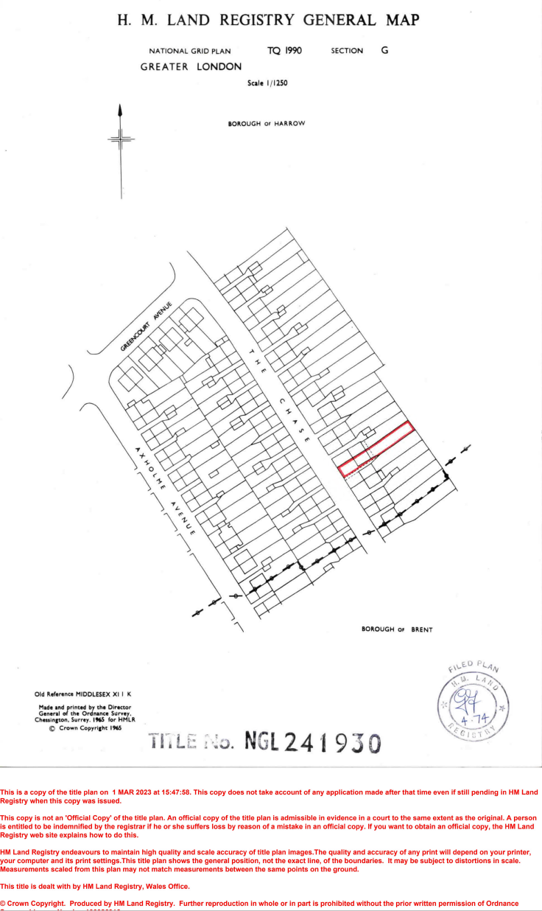

APPENDIX 3: Site Photos

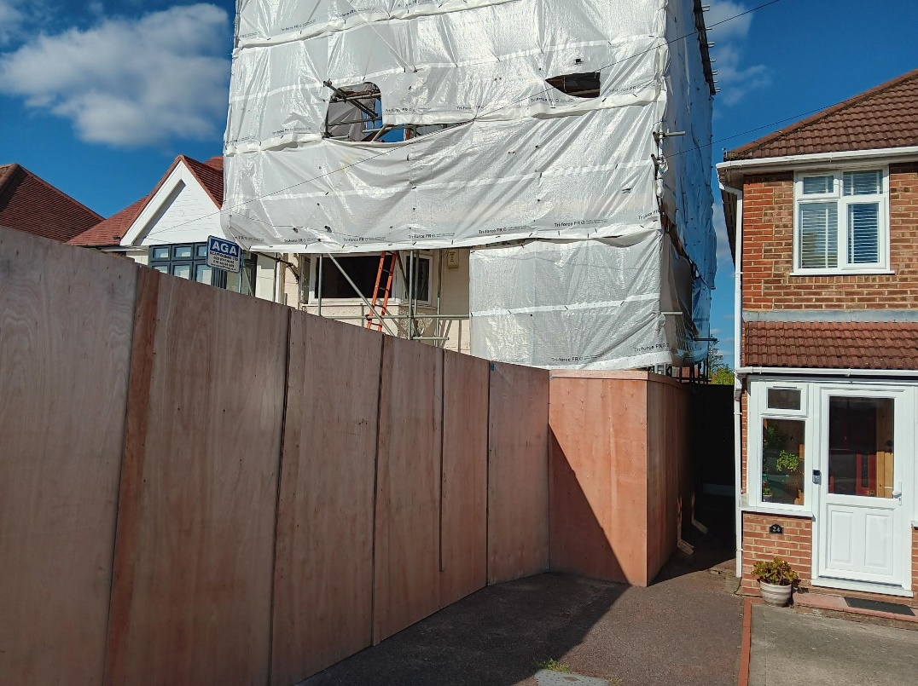
Figure 1: front of property

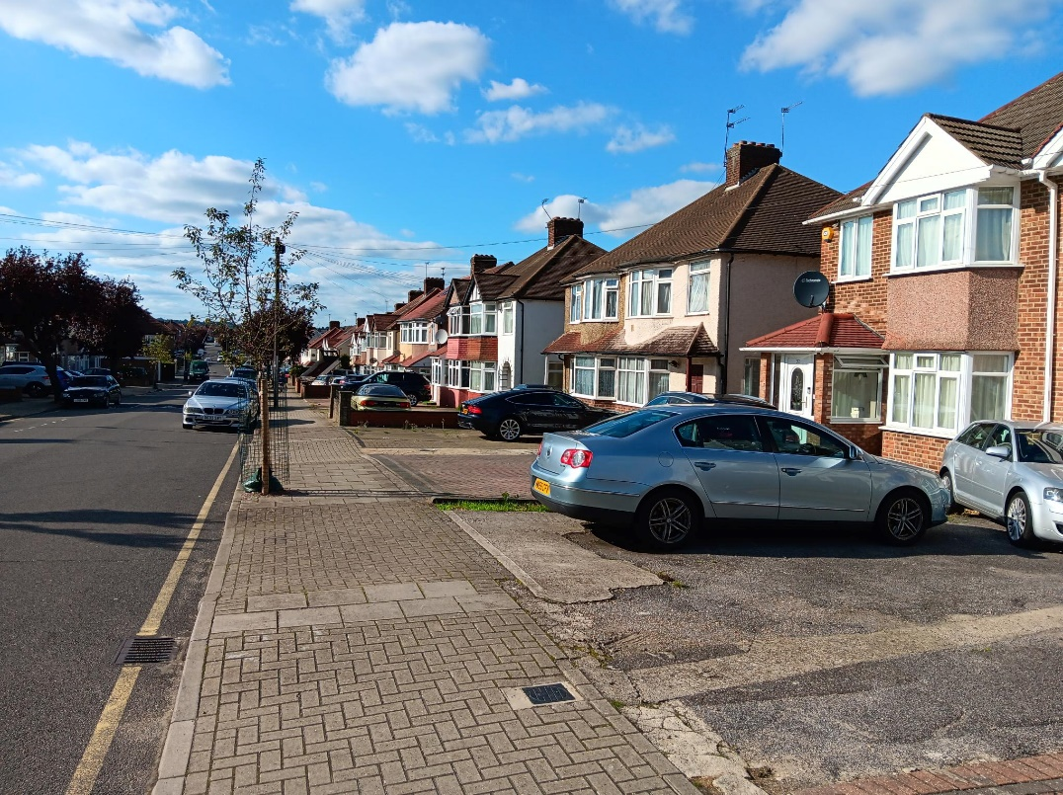
Figure 2 Street View

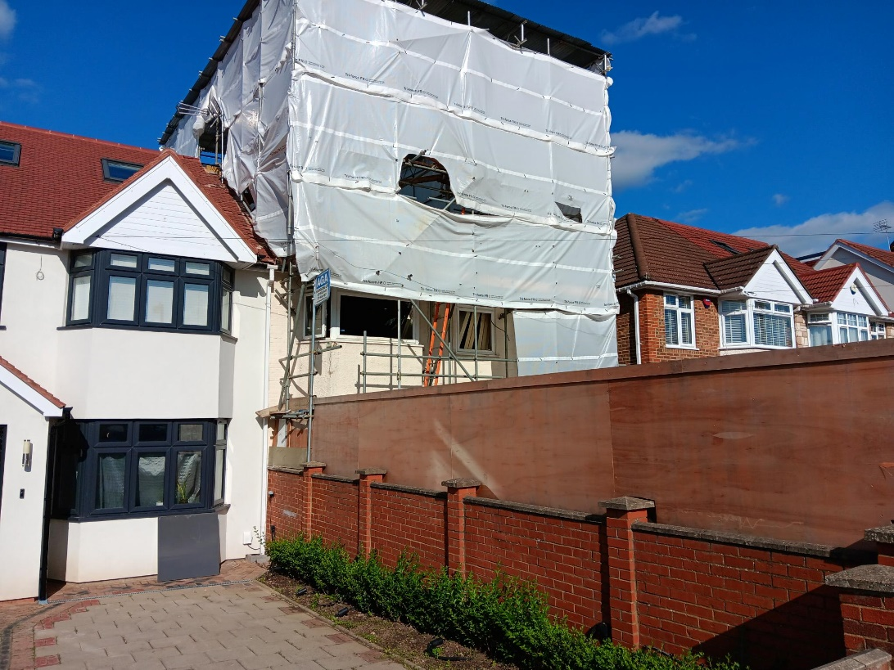
Figure 3 Front of property and adjoining semi-detached unit

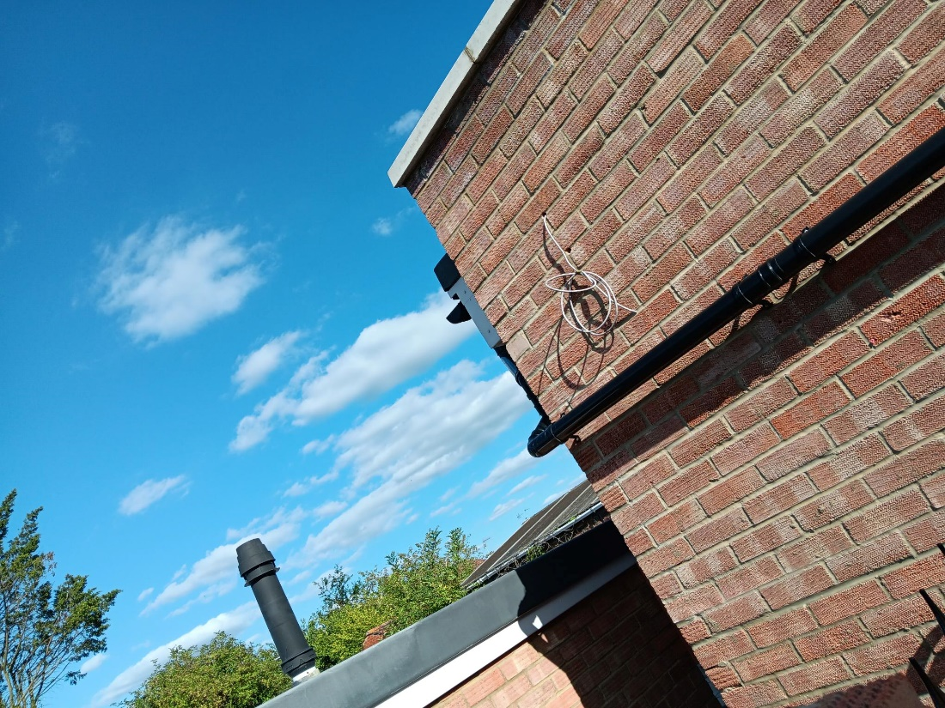
Figure 4 Adjacent property extension and host site existing rear projection/swimming pool

APPENDIX 4: Plans and elevations

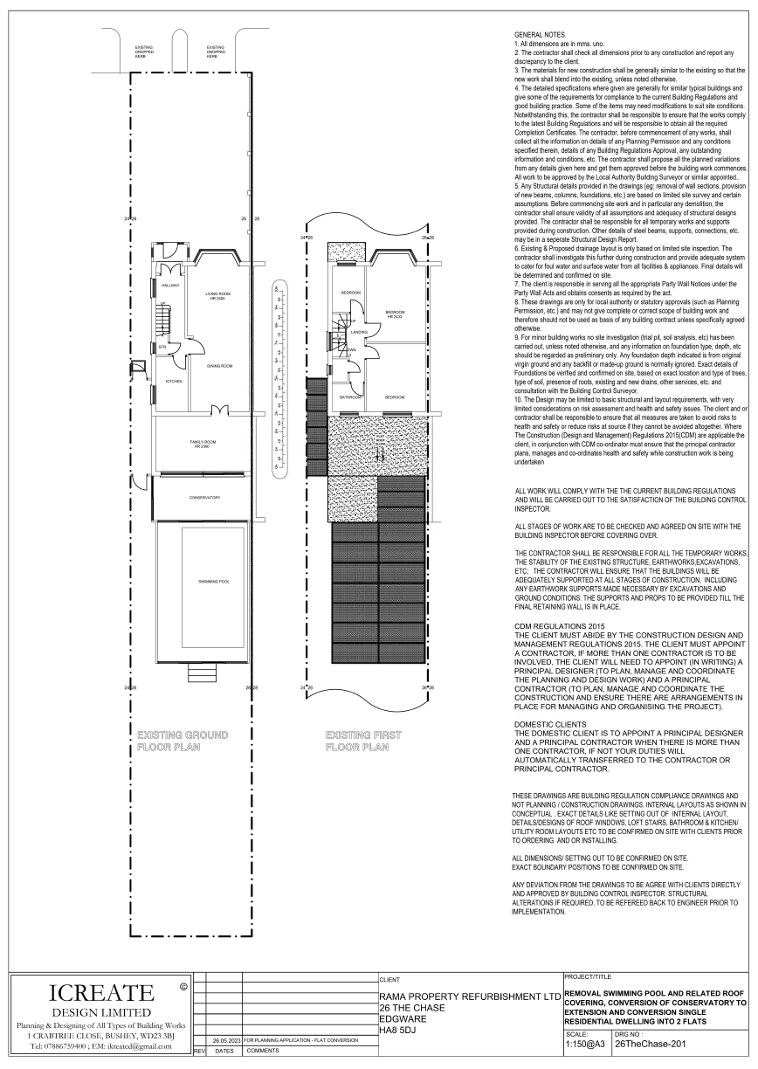

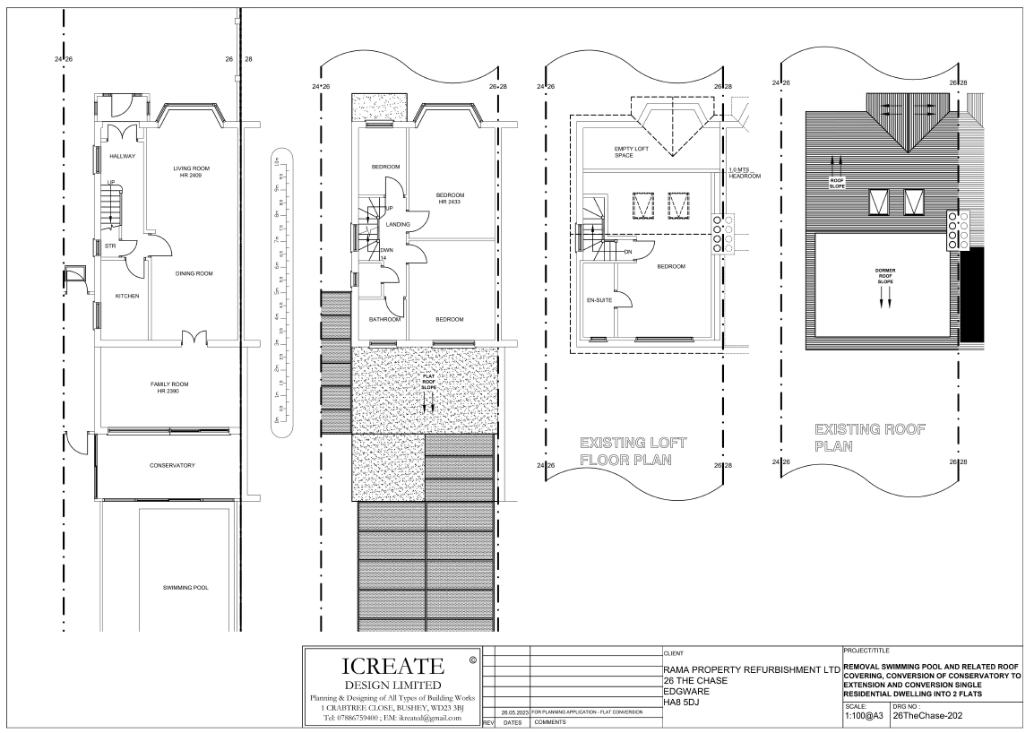

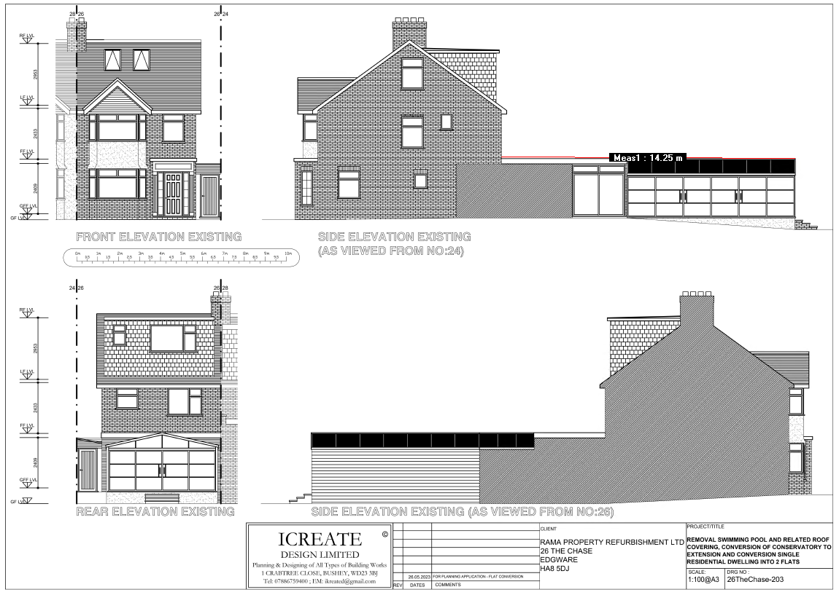
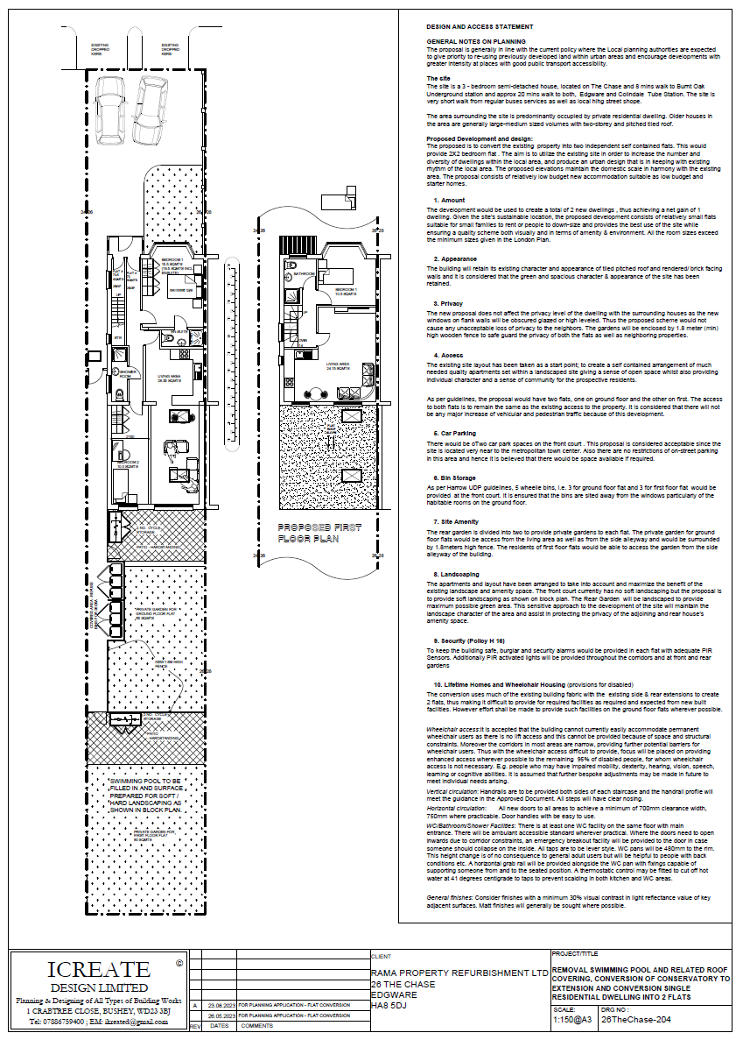

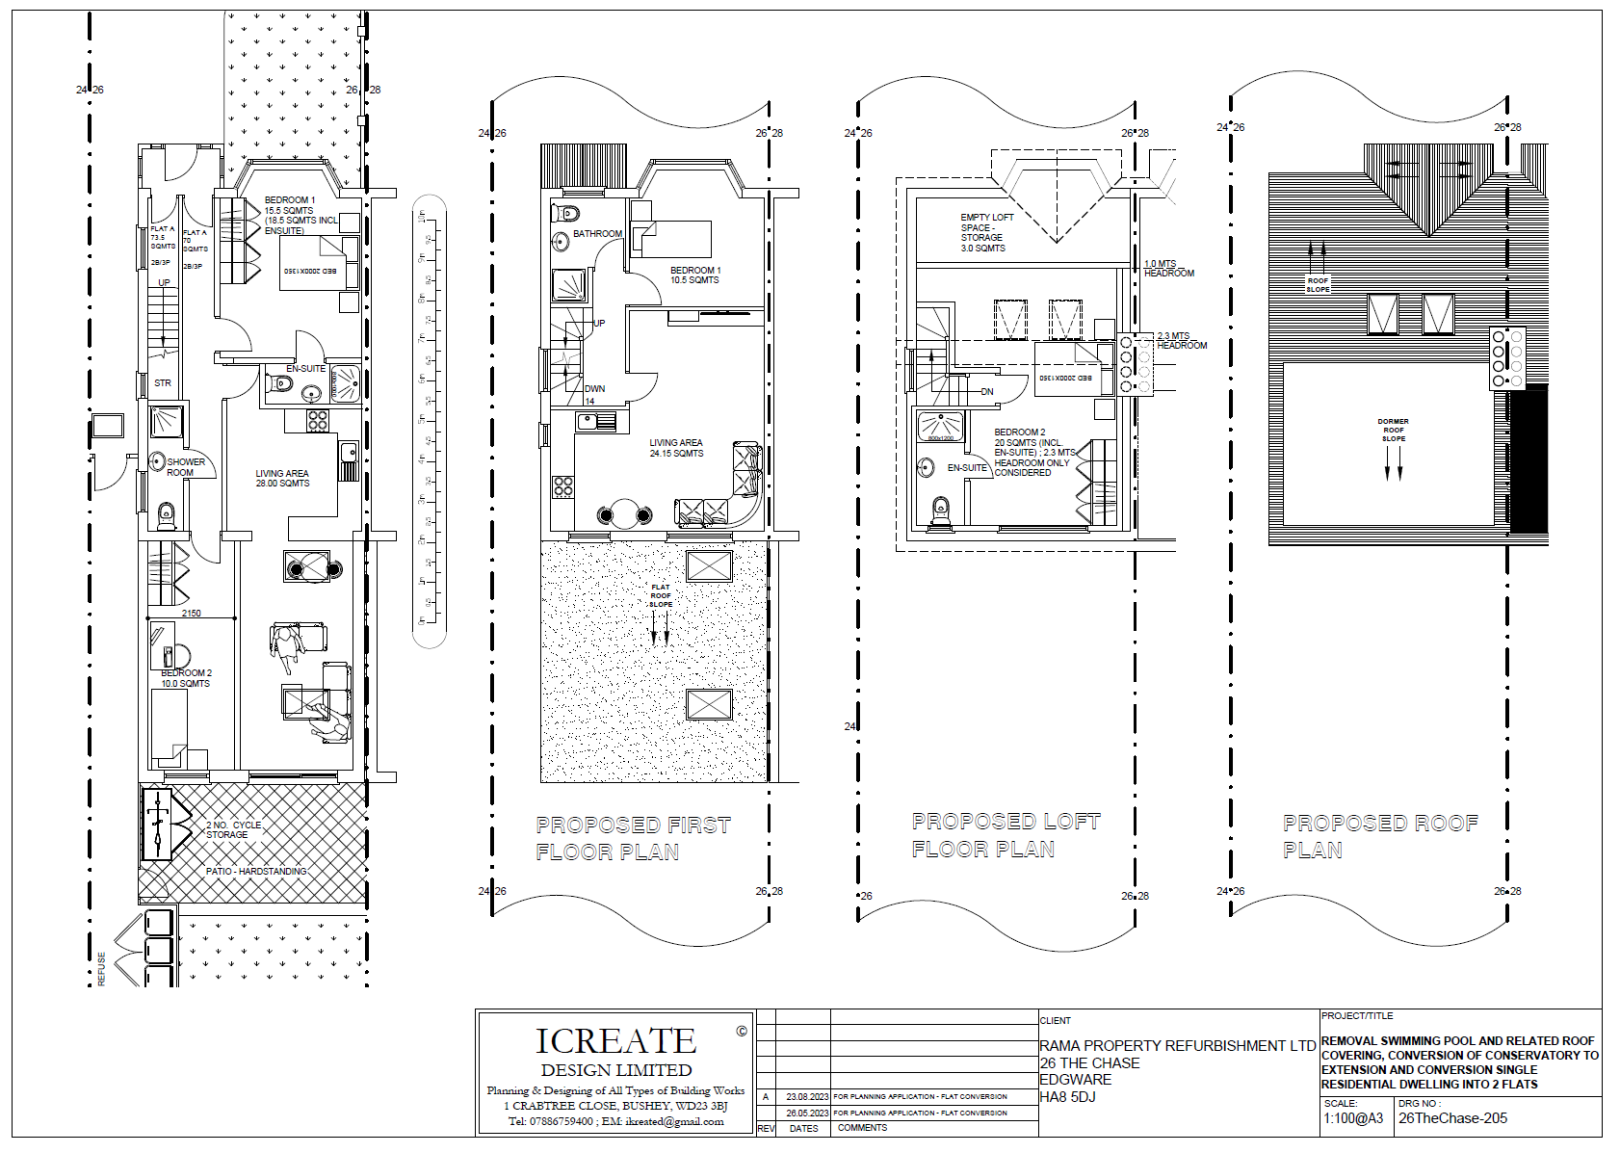
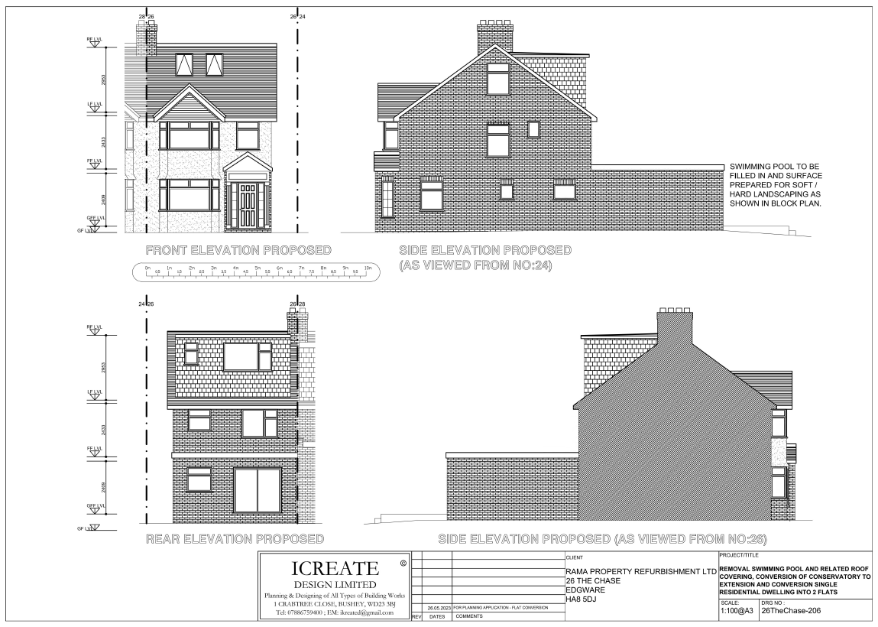

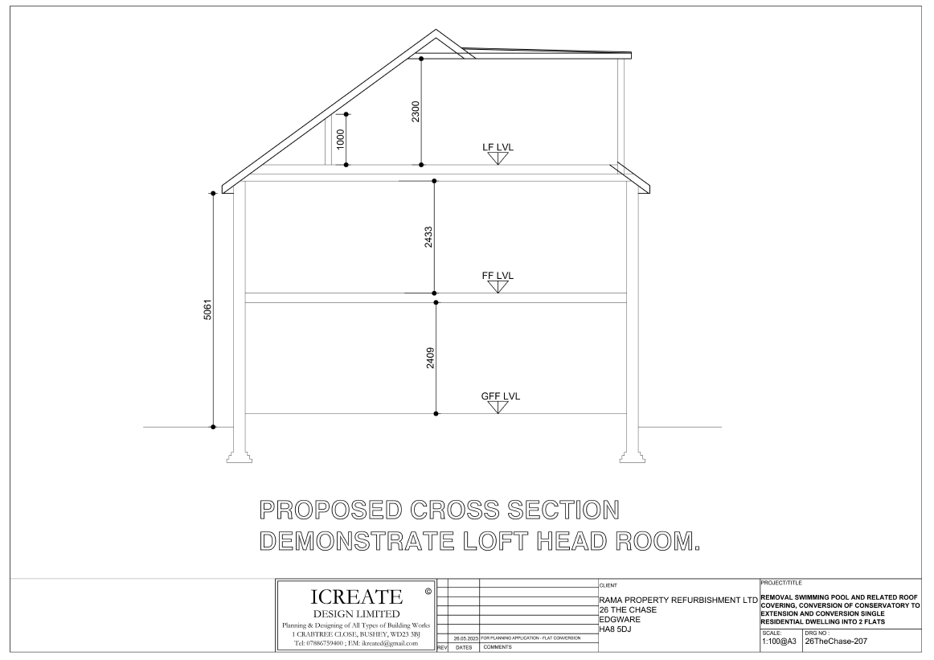

2/033 | South Car Park, Station Road, Harrow, HA1 2TB
Substitute the Site Plan drawing within Appendix 2 for the following drawing.

AGENDA ITEM 10 – REPRESENTATIONS ON PLANNING APPLICATIONS

Application | Speakers
Astley House, South Hill Avenue, Harrow. | Mrs Sheenal Olson (Objector)  Mio Kwan (Applicant) William Lee Architect – will be speaking.

